2a.
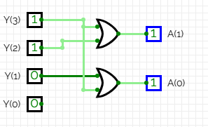
2b.
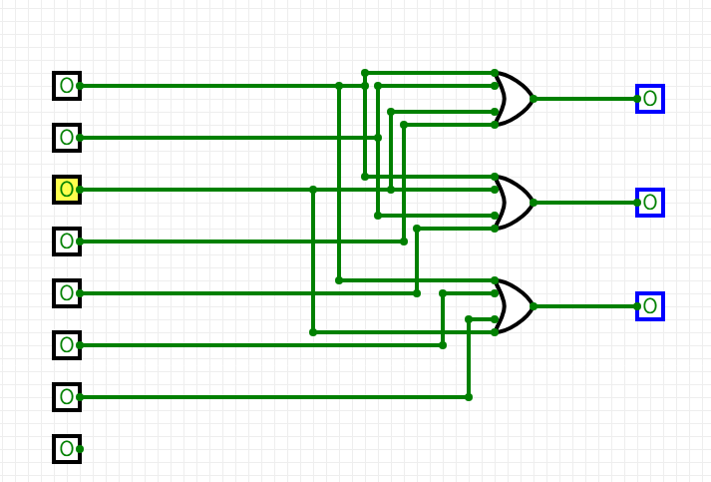

For the MSB in the output.
Y3 Y2 / Y1 Y0 | 00 | 01 | 11 | 10
00 | X | 0 | 0 | 0
01 | 1 | 1 | 1 | 1
11 | 1 | 1 | 1 | 1
10 | 1 | 1 | 1 | 1
$$A1=Y3+Y2$$

Now for the LSB

Y3 Y2 / Y1 Y0 | 00 | 01 | 11 | 10
00 | X | 0 | 1 | 1
01 | 0 | 0 | 0 | 0
11 | X | X | X | X
10 | 1 | 1 | 1 | 1

$$A0=Y3+Y3'Y1$$

